caAdapter

Regulatory Data Services Use Cases

caAdapter – 4.0


Center for Biomedical Informatics
and Information Technology

DOCUMENT REVISION HISTORY
Version Number | Date | Description
1.0 | 28 September 2007 | - Use case for Regulatory Data Service

Background/Summary
This document contains the caAdapter v. 4.0 use cases
Table of Content
caAdapter 1
Background/Summary 2
1 Introduction 5
1.1 Overview 5
1.2 Related Documents 5
2 Actors and Goals 5
2.1 HL7 Message Transformation Analyst 5
3 Use Cases 5
3.1 UC-caAdapter 4.0 – Create map from schema to define.xml 5
3.1.1 Brief Description 5
3.1.2 Primary Actor 6
3.1.3 Preconditions 6
3.1.4 Basic Flow of Events 6
3.1.5 Alternative Flow of Events 7
3.1.6 Post Conditions 7
3.2 UC-caAdapter 4.0 – Create map from SCS to define.xml 7
3.2.1 Use Case Model 7
3.2.2 Brief Description 7
3.2.3 Primary Actor 7
3.2.4 Preconditions 8
3.2.5 Basic Flow of Events 8
3.2.6 Alternative Flow of Events 8
3.2.7 Post Conditions 8
3.3 UC-caAdapter 4.0 – Convert map file into txt files 9
3.3.1 Use Case Model 9
3.3.2 Brief Description 9
3.3.3 Primary Actor 9
3.3.4 Preconditions 9
3.3.5 Basic Flow of Events 9
3.3.6 Alternative Flow of Events 10
3.3.7 Post Conditions 10
3.4 UC-caAdapter 4.0 – Open Data Viewer 11
3.4.1 Use Case Model 11
3.4.2 Brief Description 11
3.4.3 Primary Actor 11
3.4.4 Preconditions 11
3.4.5 Basic flow of events 11
3.4.6 Alternative Flow of Events 12
3.4.7 Post Conditions 12
4 Overall Requirements 13
4.1 Requirements Prioritization 13
5 Data Definitions 13
6 Sign Off 14
6.1 Approval 14

Introduction

Overview
The analyst must be able to map the schema information to define.xml using caAdapter mapping module. The analyst then uses the transformation engine to create Regulatory Data Sets (RDS) text files. The generated TXT files will be used for further processing.

Related Documents
- caCORE SDK 1.1 Programmers Guide
- caAdapter v. 4.0 Requirements Document
- caAdapter v. 4.0 Design Document

Actors and Goals

HL7 Message Transformation Analyst
- Analyst

Use Cases

UC-caAdapter 4.0 – Create map from schema to define.xml
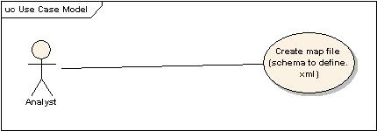

Brief Description
In this use case the actor initiates the following
- Connecting to a database and displaying the schema information in the mapping panel on the left
- Open define.xml in the mapping panel on the right
- Conduct mapping from the table columns to the SDTM fields
- Save the mapping information
- Open Dataviewer module (optional) to generate SQL statements
- The Dataviewer opens with the columns of the table pre-selected
- After tuning the SQL’s, the Dataviewer module is saved.

Primary Actor
Analyst

Preconditions
A business need to map data in a particular format to the RDS format. caAdapter must be able to access the database using JDBC. The analyst must be conversant with the data model that needs to be converted to RDS format.

Basic Flow of Events
- The schema information is extracted to the caAdapter module using JDBC.
- The table columns are mapped to the respective SDTM domains.
- When the mappings are complete the analyst is able to save the mapping file. After a successful file save, the SQL query builder module is initiated.
- The connection object is passed to the query builder and the number of the open panels corresponds to mapped domains in the saved mapping XML file.
- The analyst performs drag and drop to visually create a SQL query.
- The SQL query can be edited and tables can be added or removed from the panel.
- The analyst can verify the generated query by running the query and checking the results returned from the query.
- The SQL query is passed as a parameter along with the connection object to the transformation engine.
- The mappings XML file and SQL query is passed as parameter to transformation engine to create SDTM Text files.

Alternative Flow of Events
- If the user does not wish to use the data viewer to generate the SQL, alternate way is to choose no to the user prompt following the save action. Then the application generates the SQL’s.

Post Conditions
- The text files are processed further by the caller
- The use case ends and the connection to database are closed.
- The generated queries can be saved and reused for repeat calls.

UC-caAdapter 4.0 – Create map from SCS to define.xml

Use Case Model
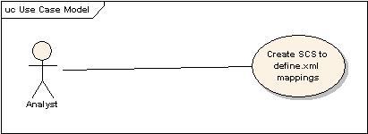

Brief Description
In this use case the actor initiates the following
- Open a SCS file in the mapping panel on the left
- Open define.xml in the mapping panel on the right
- Conduct mapping from the table columns to the SDTM fields
- Save the mapping information

Primary Actor
Analyst

Preconditions
A business need to map data in a particular format to the RDS format.

Basic Flow of Events
- The user opens a SCS file and conducts mappings.
- When the mappings are complete the analyst is able to save the mapping file.

Alternative Flow of Events
- none

Post Conditions
- The text files are processed further by the caller
- The use case ends and the connection to database are closed.
- The generated queries can be saved and reused for repeat calls.

UC-caAdapter 4.0 – Convert map file into txt files

Use Case Model
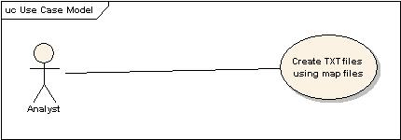

Brief Description
In this use case the actor initiates the following
- The actor chooses a map file to generate the TXT files. Depending on the type of map file, the pop window gets the password information for a database map file and location of CSV data file for SCS map file.

Primary Actor
Analyst

Preconditions
A business need to map data in a particular format to the RDS format. caAdapter must be able to access the database using JDBC.

Basic Flow of Events
- The analyst opens a map file to create the TXT files.
- Depending on the type of map file, the user is prompted for either a password or location of CSV file.
- The user is prompted to enter the location where the TXT files will be saved.

Alternative Flow of Events
- None

Post Conditions
- The TXT files with for each mapped domain will be created in the directory location specified.
- The use case ends and the connection to database are closed.

UC-caAdapter 4.0 – Open Data Viewer

Use Case Model
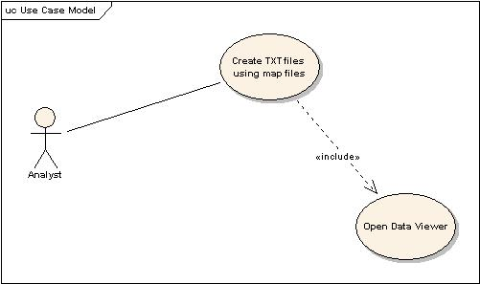

Brief Description
In this use case the actor initiates the following
- The actor chooses to open the data viewer after completing a save action.

Primary Actor
Analyst

Preconditions
The user must have completed the mapping between the schema and define.xml. The database connection must exist.

Basic flow of events
- When the user chooses to open the data viewer, a window opens showing all the mapped tables and the mapped columns will be pre-selected.
- The user can verify the selected columns and validate the sql which is generated

Alternative Flow of Events
- The user can generate the sql statements with out using the data viewer.

Post Conditions
- The map file will be saved with the SQL statements. A separate SQL statement will be generated for each mapped domain.

Overall Requirements

Requirements Prioritization

Priority | Use Case Name | Supp Requirement Ref #

Data Definitions

Sign Off

Approval

Workspace General Contractor Rep Print Name Date
Architecture Workspace Rep Print Name Date
VCDE Workspace Rep Print Name Date
Workspace Working Group Rep Print Name Date
NCI CBIIT Rep Print Name Date

